Class Meeting Times:
Section 1: November 14, 2020: 12:00 pm – 12:50 pm
Section 2: November 14, 2020: 1:00 pm – 1:50 pm

Instructors:
Ann Herman, third-year law student at Northwestern Law, ann.herman1@law.northwestern.edu
Michelle Kraus, third-year law student at Northwestern Law, michelle.kraus@law.northwestern.edu

We will be teaching you how to make easy, yet delicious french toast!

Ingredients:
8 slices of bread: your choice of bread (can be challah, brioche or white bread, etc.)
4 eggs
1 tablespoon of butter
1/4 cup of milk
1/2 teaspoon of vanilla extract
1 teaspoon of cinnamon
2 tablespoons of sugar
1/2 cup of maple syrup

Extras:
Strawberries, or other fruit
1/4 teaspoon of nutmeg
Whipped cream

Equipment:
Mixing bowl
Measuring cups and spoons
Whisk
Pan/Skillet
Spatula

Recipe:
- Beat the egg in a mixing bowl.
- Whisk in the melted butter, then slowly add the milk and vanilla, whisking to combine.
- Add the sugar while continuing to whisk until totally smooth.
- Soak each side of the bread in the batter for about 15-20 seconds.
- Heat a skillet or griddle over medium heat and spread butter all over the bottom.
- Cook the bread for about 1 minute, or until golden and flip the bread, cooking on the other side for equal time or until golden.
- Serve with your favorite syrup!
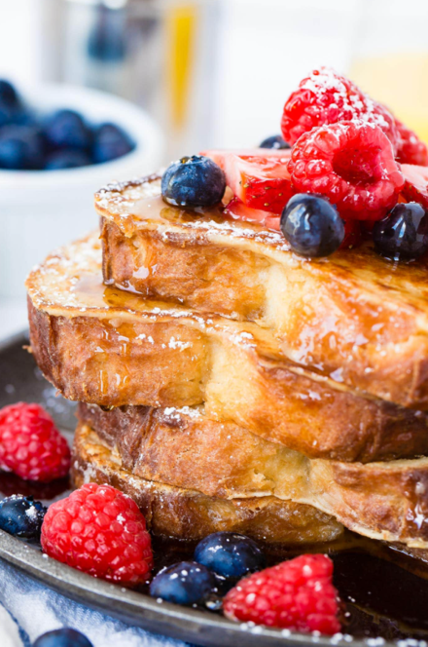

After class: Please upload a picture of your finished French Toast to this Google Drive folder!!
https://drive.google.com/drive/folders/1Urrcet-6NAmckaJa-9_P71UUlXRhA67k?usp=sharing

